Orhan Pamuk

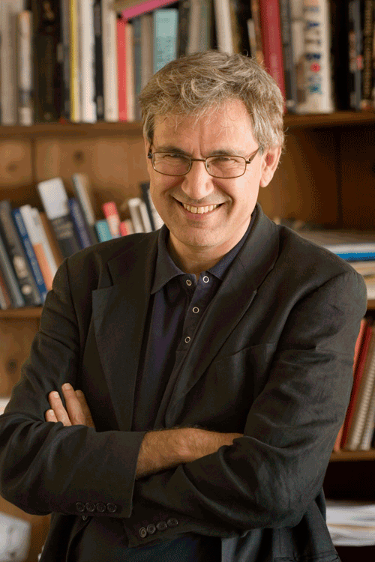

Orhan Pamuk was born in Istanbul in 1952 and grew up in a large family similar to those which he describes in his novels Cevdet Bey and His Sons and The Black Book, in the wealthy westernised district of Nisantasi. As he writes in his autobiographical book Istanbul, from his childhood until the age of 22 he devoted himself largely to painting and dreamed of becoming an artist. After graduating from the secular American Robert College in Istanbul, he studied architecture at Istanbul Technical University for three years, but abandoned the course when he gave up his ambition to become an architect and artist. He went on to graduate in journalism from Istanbul University, but never worked as a journalist. At the age of 23 Pamuk decided to become a novelist, and giving up everything else retreated into his flat and began to write.

ORANGE (TURUNCU)

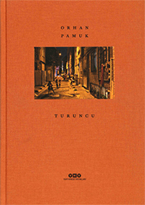

When the Nobel-Prize-winning novelist Orhan Pamuk is finished with a day’s writing, he takes his Canon 5 camera and wanders through the backstreets of his home town, spaces that seem neclected and forgotten, washed in a particular light. This is the orange light of the windows and streetlamps that Pamuk knows so well from his childhood in Istanbul 50 years ago, as he tells in his introduction. Yet Pamuk also observes how the homely, cozy orange light is slowly being replaced by a new, artificial-bright and crude-white from the more modernized light bulbs.

BALKON

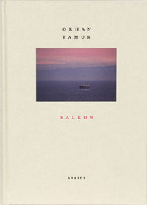

In the winter of 2011 Nobel-Prize-winning Turkish novelist Orhan Pamuk took 8,500 color photographs from his balcony with its panoramic view of Istanbul, the entrance of the Bosphorus, the old town, the Asian and European sides of the city, the surrounding hills, and the distant islands and mountains. Sometimes he would leave his writing desk and follow the movements of the boats as they passed in front of his apartment and sailed far away.

FATHER, MOTHER AND SON

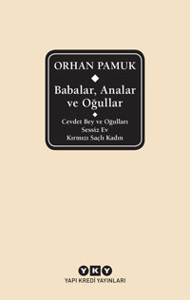

**Fathers, Mothers and Sons**(2018), first volüme of Orhan Pamuk’s collected Works in “Delta” omnibüs contains his last bestselling novel The Red-Haired Woman (2016) along with his first two novels, Cevdet Bey and His Sons (1982) and The Silent House (1983).Fathers, Mothers ans Sons, with a new twenty-pages-long conversation with Pamuk on family sagas and multi-generational novels, is a handy gift for Pamuk’s new and passionate readers.

INNOCENCE OF MEMORIES

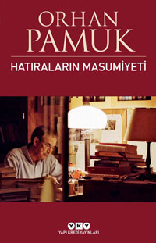

In Innocence of Memories, Orhan Pamuk revisits Kemal and Füsun’s love story through the eyes of Ayla, a character from The Museum of Innocence. Pamuk’s story about Ayla is accompanied by the magical images from Grant Gee’s film on Museum of Innocence, Istanbul, and Pamuk. The book also includes new texts written by Pamuk and interviews in which he evaluates the experiences of the novel, the museum and the film. Innocence of Memories is a film book on love, Istanbul and remembrance…

In 2012, British film-maker Grant Gee and Orhan Pamuk started collaborating on a documentary about Istanbul and Pamuk’s world. The result is a poetic documentary that was received by critics with intense praise at its premiere at Venice Film Festival.

“A mesmerising, original meditation on love and the city” – The Guardian

THE RED-HAIR WOMAN

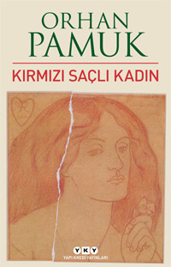

Orhan Pamuk’s tenth novel, The Red-Haired Woman is the story of a well-digger and his apprentice looking for water on barren land. It is also a novel of ideas in the tradition of the French conte philosophique.In mid-1980s Istanbul, Master Mahmut and his apprentice use ancient methods to dig new wells; this is the tale of their back-breaking struggle, but it is also an exploration—through stories and images—of ideas about fathers and sons, authoritarianism and individuality, state and freedom, reading and seeing. This short, compelling novel is at once a realist text investigating a murder which took place thirty years ago near Istanbul, and a fictional inquiry into the literary foundations of civilizations, comparing two fundamental myths of the West and the East respectively: Sophocles’s Oedipus Rex (a story of patricide) and Ferdowsi’s tale of Rostam and Sohrab (a story of filicide).Throughout runs the demonic voice of the eponymous red-haired woman.

ILLUSTRATED ISTANBUL

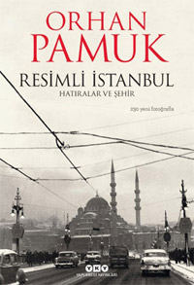

Illustrated Istanbul is a magnificent volume of 450 black and white photographs of the city curated by Orhan Pamuk, an enriched edition of his memoir Istanbul: Memories and the City.

In the twelve years since the publication of Istanbul: Memories and the City, Orhan Pamuk has continued to add to his collection of photographs of Istanbul on themes like melancholy, the black-and-white aesthetic, provincial poverty, post-imperial despondency, and the desolation of architectural ruin. Now, Pamuk has selected a range of photographs from this collection for Illustrated Istanbul, linking each new image to his memoir.

This lavish selection of 450 photographs, featuring contributions from Ara Güler and Henri Cartier-Bresson, the Greek Samancı Brothers, itinerant European photographers, and local news reporters, and dipping into the archives of Istanbul’s characteristic photography collectors, also contains previously unpublished family photographs from the author’s own archives. It is a sumptuous volume, a collection of dreamlike images of Istanbul chosen by Pamuk himself.

**BLACK BOOK-25TH ANNIVERSARY SPECIAL EDITION**

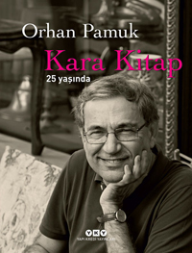

First published in Turkish in 1990, The Black Book came to be a milestone not only in the career of Orhan Pamuk but also in the last forty years of Turkish literature. This special 25th anniversary edition includes pages and sketches from the novel’s manuscripts, many of which are published here for the first time.

**A STRANGENESS IN MY MIND**

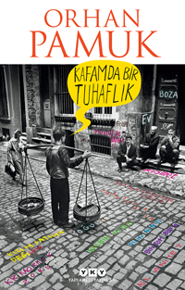

“A STRANGENESS IN MY MIND”, Orhan Pamuk’s ninth novel, is both an unforgettable love story and a modern epic.

Mevlut Karataş, the novel’s hero, is a street vendor who sells boza, a traditional Turkish beverage. The novel follows the love story between Mevlut and his girlfriend whom he wrote letters for three years, as well as Mevlut’s life in the streets of Istanbul throughout a period that spans over four decades, from 1969 to 2012, during which Mevlut works in a range of different jobs by day and sells boza during winter nights. Throughout these decades, Mevlut witnesses the various transformations the city, the people and Turkey in general undergo. All the while, Mevlut often wonders what the source of this “strangeness” in his mind is – a strangeness that makes him different from all the others.

“A Strangeness in My Mind”, a story told from the perspectives of various characters, is destined to be one of the most widely read novels of Pamuk, as well as one of his greatest achievements.

**I AM A TREE**

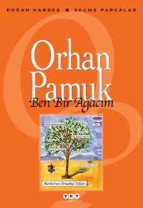

This small book is a selection of Pamuk’s favorite pieces from his own books: Selections from The Black Book, My Name is Red, Snow, and Istanbul, pieces that can be read as stories in themselves. I am a Tree might best be summarized with the sentence “Orhan Pamuk for everyone”, and it is indeed the best introduction to Pamuk’s rich fictional and nonfictional output. The book also contains a surprise: A long chapter from Pamuk’s new and still unpublished novel, A Strangeness in My Mind, that tells the story of the school days of the novel’s protagonist, Mevlut Karataş.